**CURRICULUM VITAE**

**PERSONAL DATA**

**NAME** **:** Jephunneh C. Mabini

**DATE OF BIRTH :** December 07, 1990

**ADDRESS :** 063 Sitio Riles, Basak, Mandaue City,

Cebu 6014, Philippines

**GENDER :** Male

**CIVIL STATUS :** Single

**EMAIL :** mcjeph@gmail.com

**CONTACT NUMBER :** 09120752272

**EDUCATIONAL BACKGROUND**

**COLLEGE :** Bachelor of Science in Information Technology

University of Cebu – Banilad Campus

Banilad, 6000 Cebu City, Philippines

School Year 2017 – Present

**HIGH SCHOOL :** Antique National High School

San Jose de Buenavista, Antique, Philippines

School Year 2006 - 2008

Mandaue City Comprehensive National High School

Jose L.Briones, Mandaue City, 6014 Cebu

School Year 2004 - 2006

**ELEMENTARY :** Basak Elementary School

Basak, Mandaue City, Philippines

School Year 1997 – 2004

**PERSONAL DATA**

**NAME** **:** Cristian G. Paragoso

**DATE OF BIRTH :** December 11, 1986

**ADDRESS :** 296-M Gonzales Compound,

Gorordo Ave., Brgy. Camputhaw,

Cebu City, 6000

**GENDER :** Male

**CIVIL STATUS :** Single

**EMAIL :** cparagoso@gmail.com

**CONTACT NUMBER :** 09158416454

**EDUCATIONAL BACKGROUND**

**COLLEGE :** Bachelor of Science in Information Technology

University of Cebu – Banilad Campus

Banilad, Cebu City

School Year 2012 – Present

Bachelor of Science in Electronics & Communications Engineering

University of San Jose – Recoletos

Magallanes St., Cebu City

2003 - 2009

**HIGH SCHOOL :** The Sisters of Mary Boystown School

Tungkop, Minglanilla, Cebu

School Year 1999 - 2003

**ELEMENTARY :** Tungkop Elementary School

Tungkop, Minglanilla, Cebu

School Year 1993 – 1999

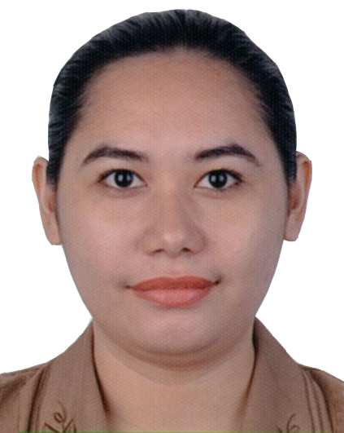**PERSONAL DATA**

**NAME** **:** Rhea Shange M. Chiong

**DATE OF BIRTH :** July 22, 1992

**ADDRESS :** 0440 Sitio BACA, Apas, Cebu City

**GENDER :** Female

**CIVIL STATUS :** Single

**EMAIL :** rheashanechiong@gmail.com

**CONTACT NUMBER :** 09225011284

**EDUCATIONAL BACKGROUND**

**COLLEGE :** Bachelor of Science in Information Technology

University of Cebu – Banilad Campus

Banilad, Cebu City

School Year 2017 – Present

Bachelor of Science in Computer Science

University of the Philippines Cebu

Gorordo Ave., Lahug, Cebu City

School Year 2009 – 2014

**HIGH SCHOOL :** University of the Philippines High School Cebu

Gorordo Ave., Lahug, Cebu City

School Year 2005 – 2009

**ELEMENTARY :** Cebu Bradford School

340 – P Ascencion Street, Urgello, Cebu City

School Year 1999 – 2005